- Our sentiment data, developed with Penta, suggests that labour market conditions have loosened and pay growth has slowed abruptly through the summer. If this trend is reflected in official data, it could motivate some Monetary Policy Committee members to join Swati Dhingra in voting for rate cuts at successive meetings.
- Most of the individual sentiment indicators for labour market-related topics used in our nowcasts have fallen sharply in recent months. The one exception is talent and HR, suggesting firms continue to place a high value on retaining staff.
- Though official data shows much lower unemployment and higher employment in recent months, we think this is misleading, and is symptomatic of the data volatility problems that the Office for National Statistics continues to battle. In our view, the picture painted by our nowcasting model is a more accurate depiction of current labour market conditions.
In its latest update in July, the Office for National Statistics announced that methodological improvements to the Labour Force Survey will take at least six months longer to implement than it had originally hoped. Even in a best-case scenario, this means the UK will have been without reliable data for 18 months for its headline measures of employment and unemployment, as well as a host of other labour market indicators. What's more, the data deficiency has coincided with a period when the tightness of the labour market is central to the decision-making of the Bank of England's Monetary Policy Committee.
We have filled the void with our proprietary high-frequency sentiment dataset, developed in collaboration with Penta. Our latest update based on data for September shows that most of the individual sentiment series for labour market-related topics used in our nowcasting indicators have fallen sharply in recent months (Chart 1).
Chart 1: Labour market sentiment has deteriorated sharply in recent months
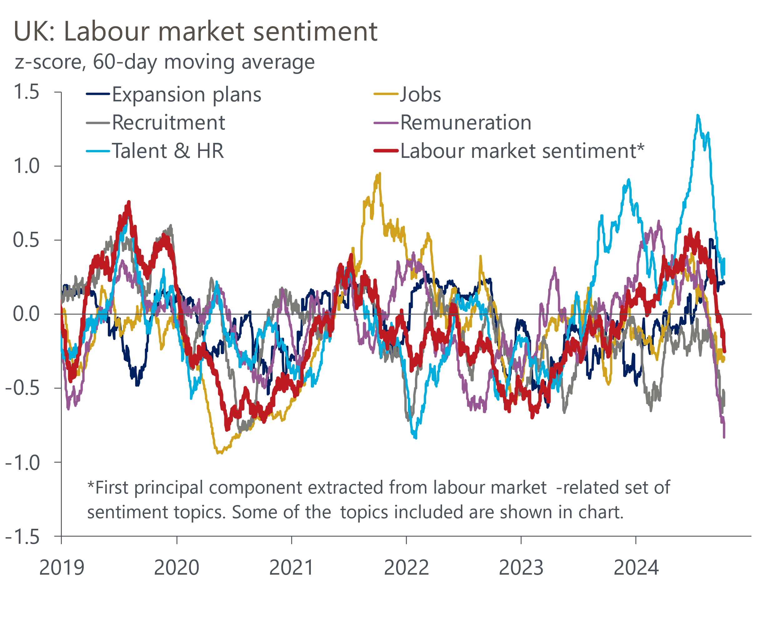
Source: Oxford Economics, Penta

There's been a notable divergence between the scores for talent and HR and recruitment. That the talent and HR score remains above its long-run average suggests that firms continue to place a high value on retaining staff. But with the recruitment score well below historical norms, many firms are not expanding headcount. This is consistent with ONS data, which shows low redundancies and falling vacancies.

The labour market is probably looser than LFS data suggest
Our sentiment data-based employment nowcast had shown employment growth steadily cooling for much of the past two years, but it has stabilised recently. We think this is consistent with firms seeking to retain staff (Chart 2). Still, our indicator suggests labour demand is weaker than either of the ONS series or HMRC's measure of payrolled employees report.
Chart 2: Our sentiment-based nowcast shows weaker labour demand than other sources
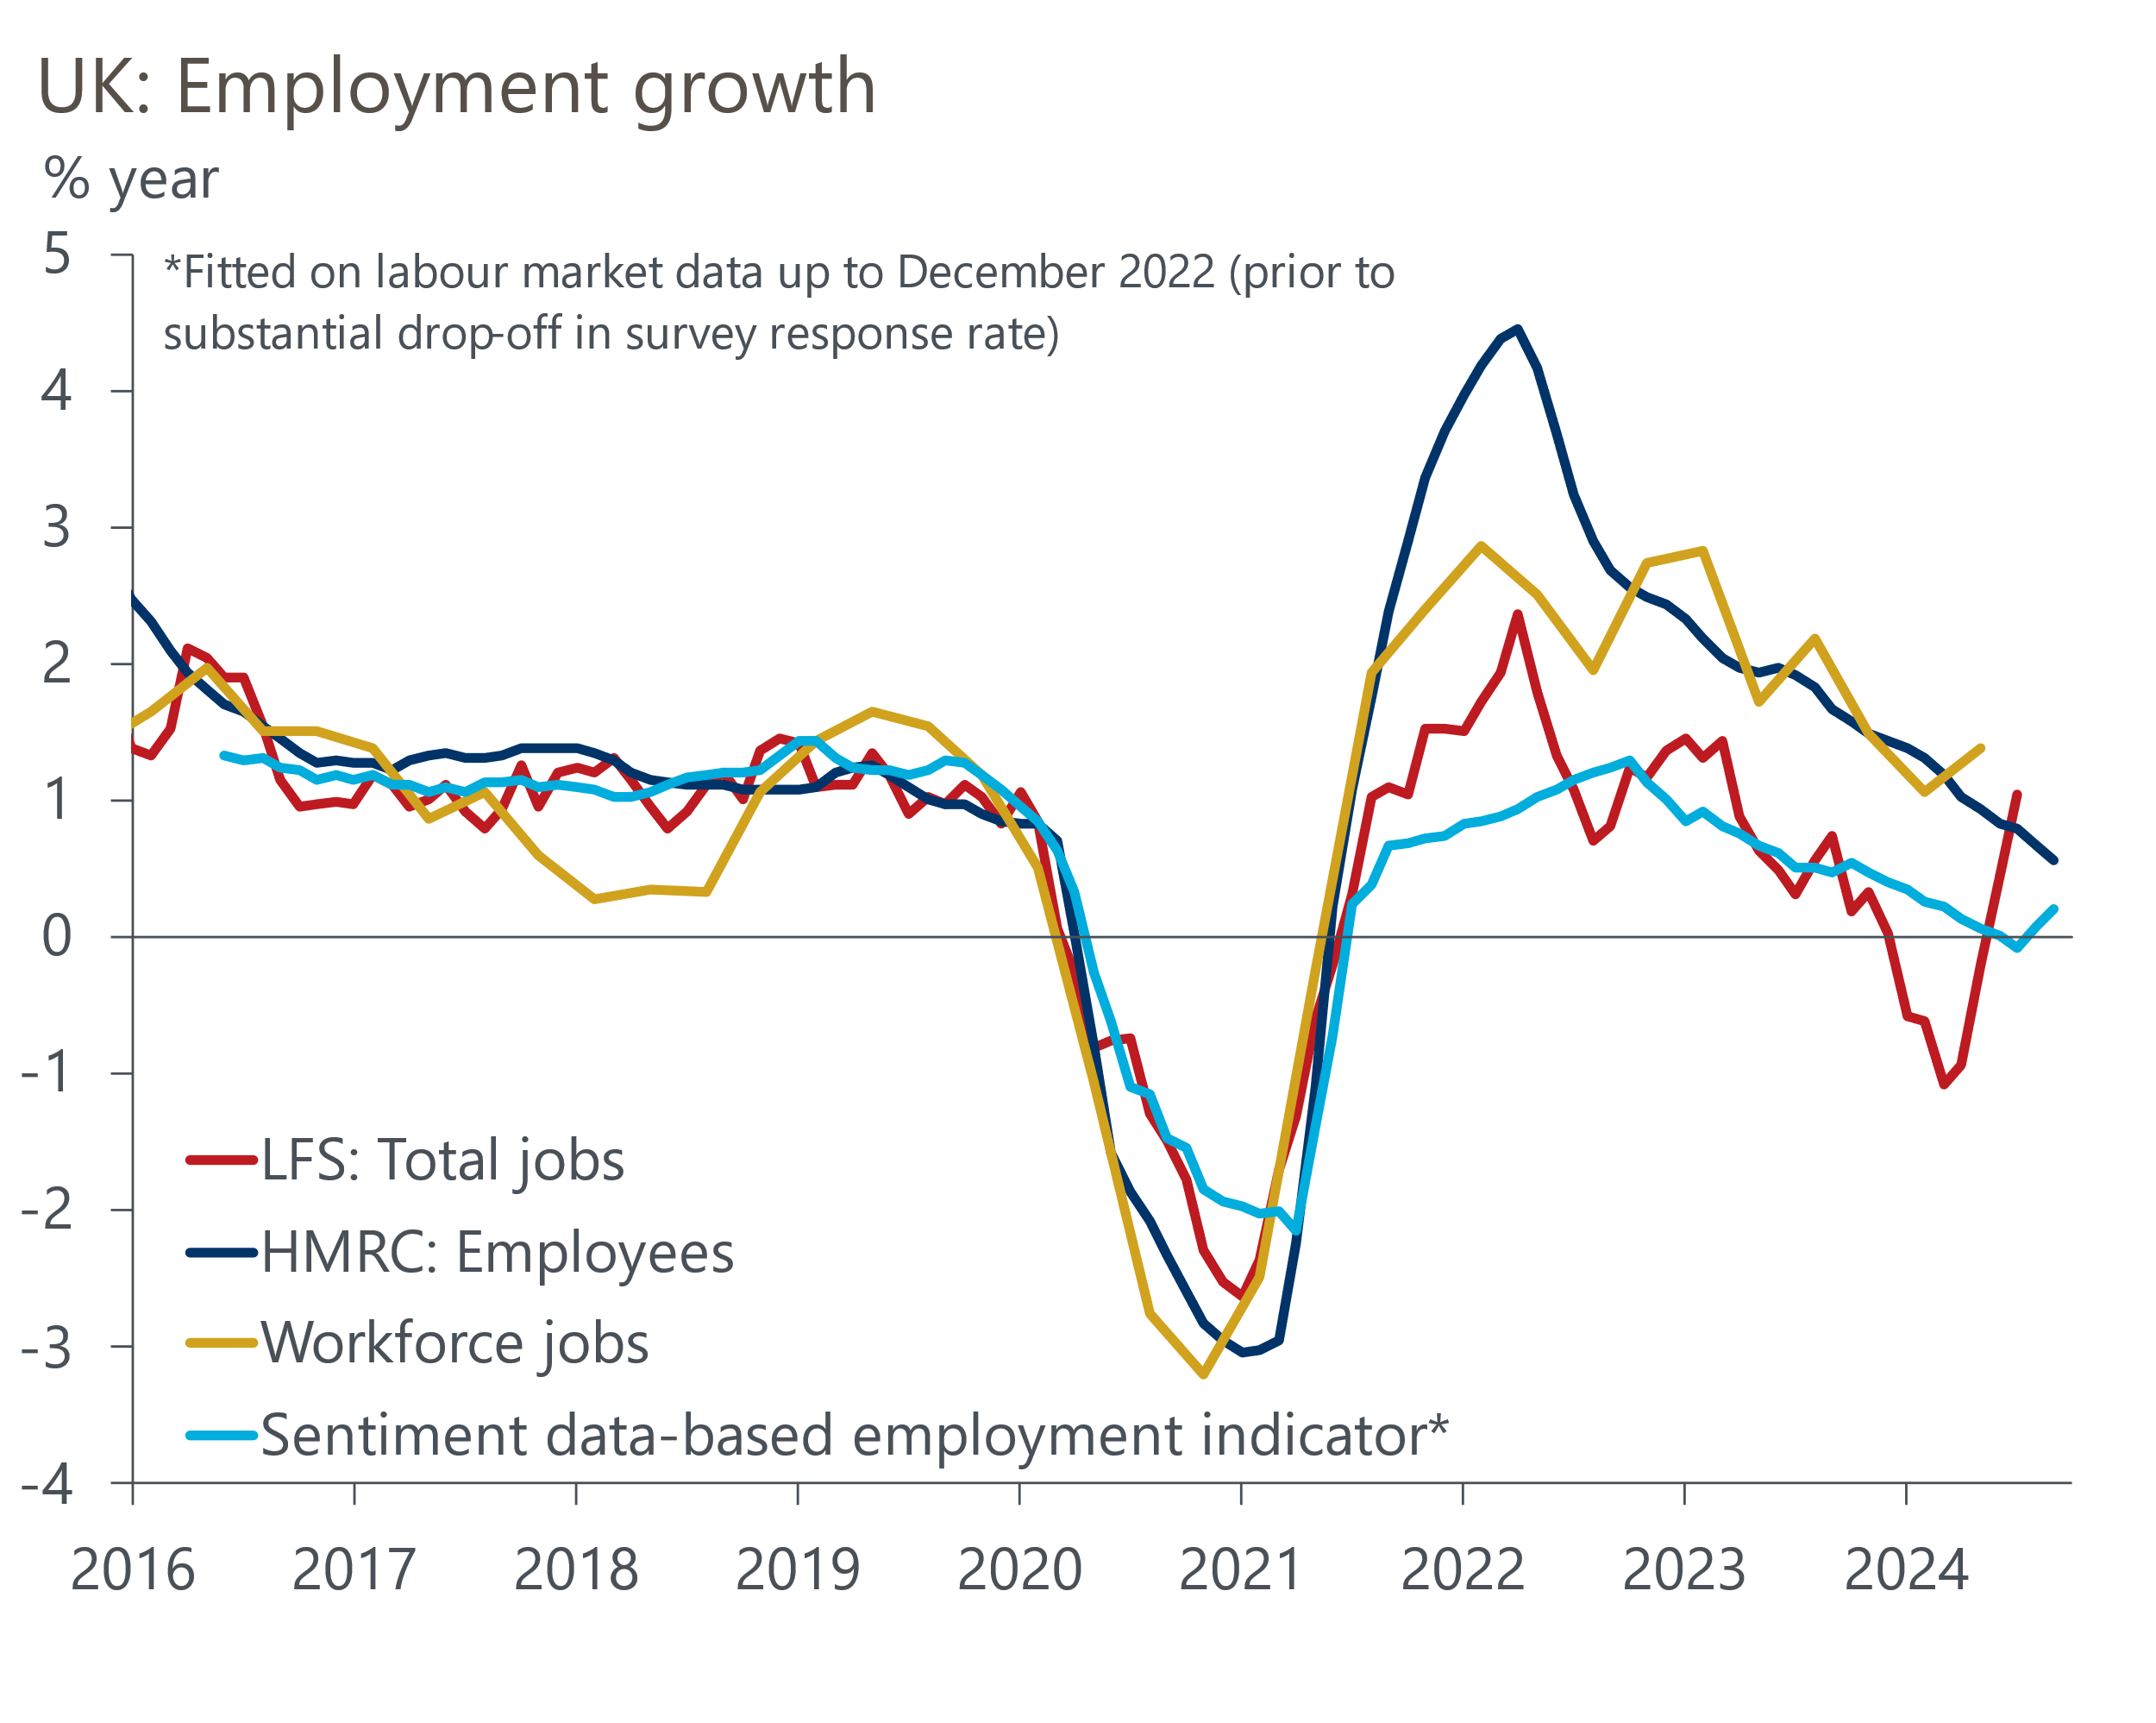
Source: Oxford Economics, Penta, Haver Analytics
The LFS problems mean we don't have reliable data on labour supply. But widespread evidence of cooling labour demand means we think the recent downward trend in the unemployment rate is almost certainly misleading (Chart 3). The single-month estimates that underpin the latest three-month average of 4% demonstrate the scale of the volatility problem that the ONS is struggling to tackle, with the three estimates ranging from 3.7% to 4.3%. When June's very low reading drops out of the three-month average next month, the unemployment rate will spike up again.
Chart 3: Labour Force Survey data remains beset by volatility
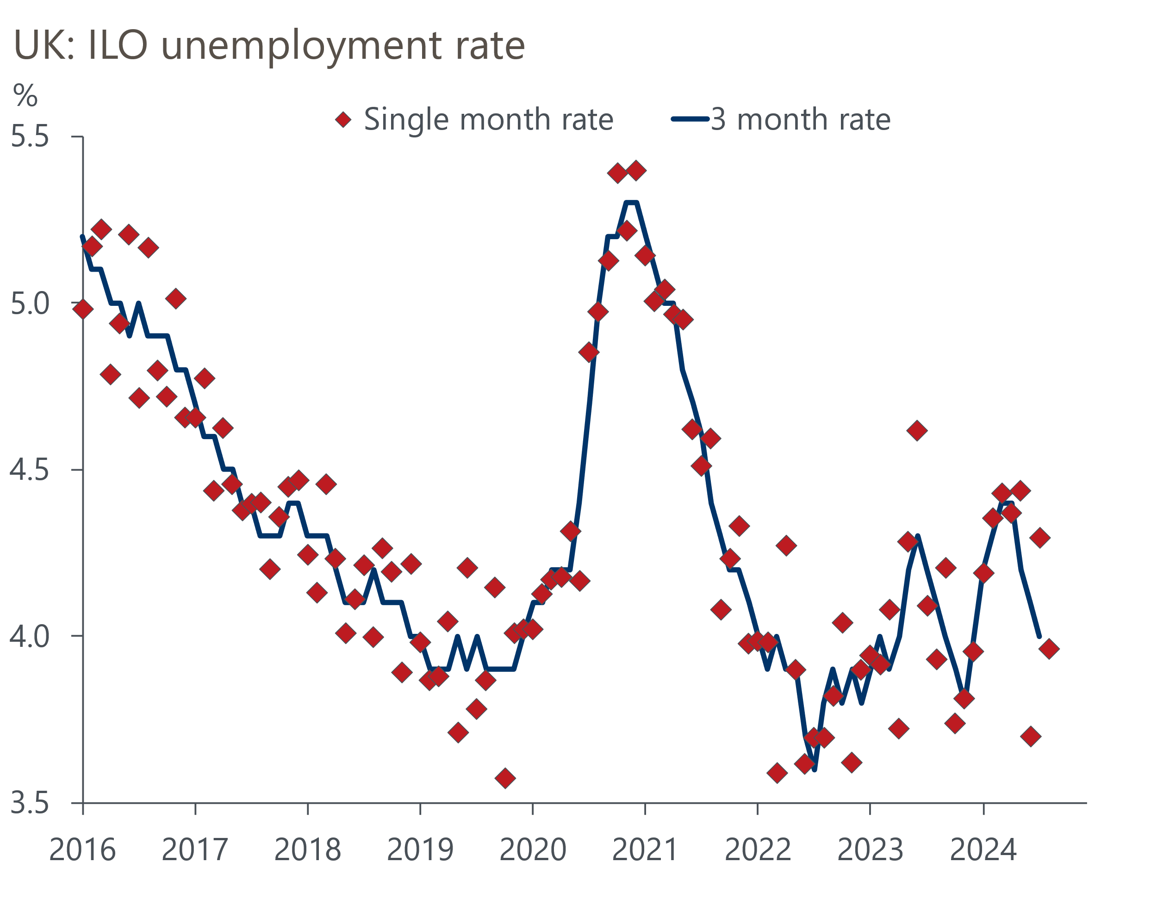
Source: Haver Analytics
The single-month observations resemble a collection of random dots with no obvious trend or pattern. So it's clear that this data offers little insight into what's currently happening in the labour market. We think the most likely story is that labour market conditions are continuing to gradually loosen, with strong inward migration flows keeping labour supply growing, while labour demand continues to soften.

Pay growth has cooled significantly compared with a year ago
Official data has shown a steady drop in headline (three-month average of the annual rate) private sector regular pay growth this year, partly reflecting strong base effects and partly due to cooling momentum. The steep decline in our sentiment score for remuneration is reflected in our nowcast showing a more abrupt slowdown in pay growth than official data during the summer. Our pay indicator has subsequently stabilised at around 4% year-on-year (Chart 4). The Brightmine (formerly XpertHR) survey tells a similar story to our indicator.
Chart 4: Our wage indicator reports a marked slowdown in pay growth
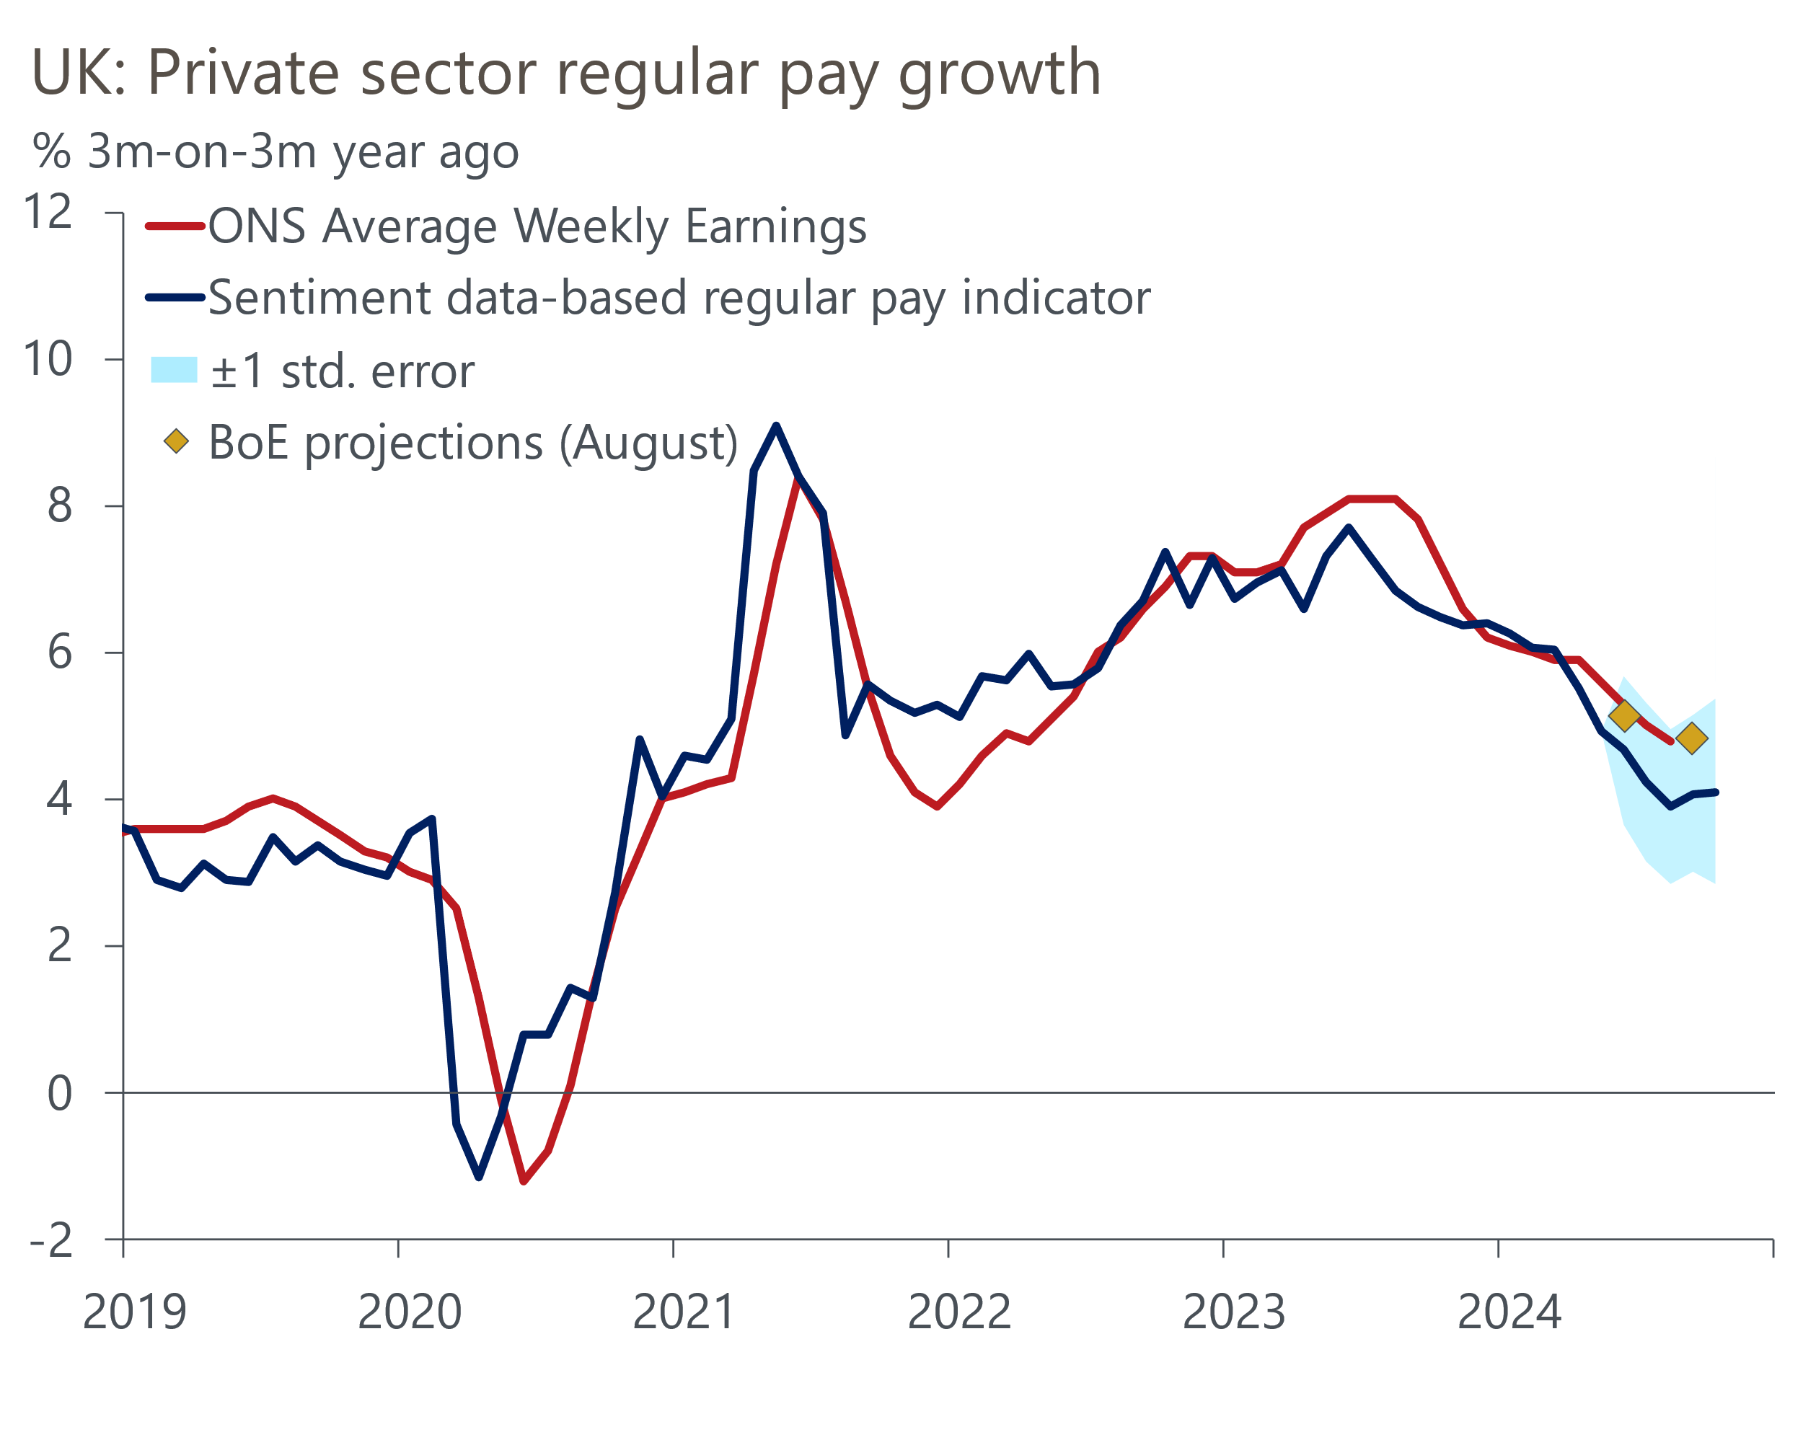
Source: Oxford Economics, Penta, Haver Analytics

Nowcasts add to the case for faster rate cuts
In recent meetings, the MPC has split into three distinct camps. The more hawkish minority has opposed rate cuts on the basis that measures of underlying domestic inflationary pressures have become well entrenched and there's a risk that enduring structural changes could ensure they persist unless the jobless rate rises significantly.
In contrast, most of the dovish majority were more confident that underlying inflationary pressures were dissipating even without a significant rise in unemployment, to the extent that they felt comfortable reducing the degree of policy restrictiveness. Swati Dhingra thinks that the MPC risks falling behind the curve given the lags in policy transmission and has voted for successive rate cuts.
For the majority, lingering uncertainty about the strength of underlying inflation pressures has prompted a cautious approach to rate cuts. But if official data follows the path of our nowcasts, with labour market conditions continuing to loosen and pay growth slowing towards a target-consistent pace, some of this group could be motivated to join Dhingra in adopting a more aggressive approach to loosening policy.
Still, the MPC would also have to consider the effects on the economy of the measures announced in the Budget on October 30. A wide range of outcomes are possible given the Chancellor appears to be open to changing the fiscal rules. So while we think the MPC would be keen to respond to signs that pay is slowing more abruptly than anticipated with quicker rate cuts, Budget decisions will also be influential.

